Name - Gaurang A Raorane Div - D15A Roll no - 49 Batch - C

**Experiment - 5**

**Aim:-** To perform regression analysis on a dataset.

**Problem Statement:-**

Regression Analysis

a) Perform Linear and Logistic regression to find out relation between variables

b) Apply regression model technique to predict the data on above dataset.

**Theory:-**

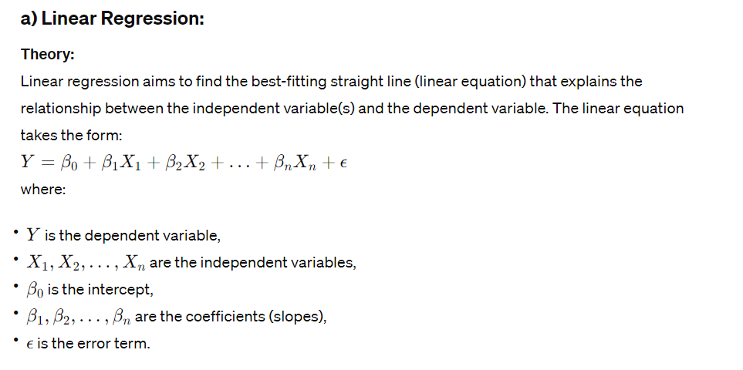

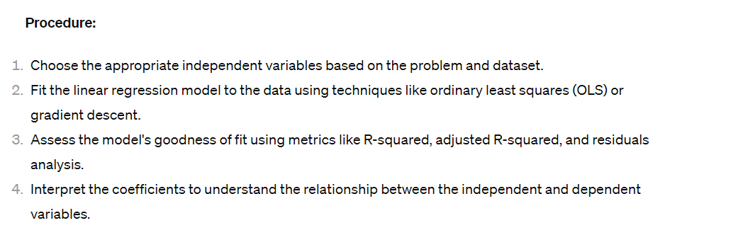

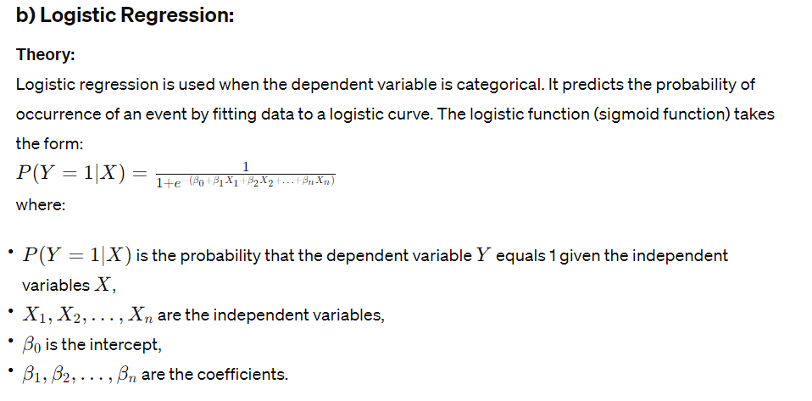

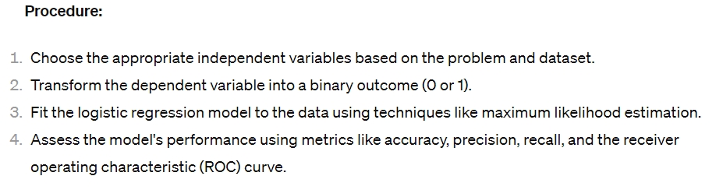

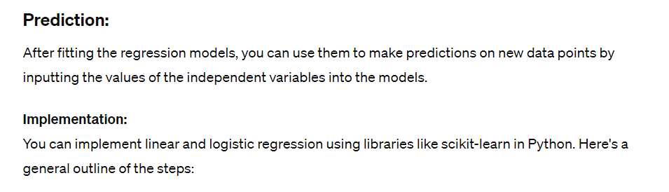

**Input:-**

X_linear = df[['Latitude', 'Longitude', 'Precip', 'Pressure', 'Humidity_2m', 'Temp_2m']] # Features

y_linear = df['MaxTemp_2m'] # Target variable

X_train_linear, X_test_linear, y_train_linear, y_test_linear = train_test_split(X_linear, y_linear, test_size=0.2, random_state=42)

linear_reg_model = LinearRegression()

linear_reg_model.fit(X_train_linear, y_train_linear)

y_pred_linear = linear_reg_model.predict(X_test_linear)

mse_linear = mean_squared_error(y_test_linear, y_pred_linear)

print("Linear Regression Mean Squared Error:", mse_linear)

X_logistic = df[['Latitude', 'Longitude', 'Precip', 'Pressure', 'Humidity_2m', 'Temp_2m']] # Features

y_logistic = df['District'] # Target variable (assuming 'District' is categorical)

label_encoder = LabelEncoder()

df['District_binary'] = label_encoder.fit_transform(df['District'])

X_train_logistic, X_test_logistic, y_train_logistic, y_test_logistic = train_test_split(X_logistic, df['District_binary'], test_size=0.2, random_state=42)

logistic_reg_model = LogisticRegression()

logistic_reg_model.fit(X_train_logistic, y_train_logistic)

y_pred_logistic = logistic_reg_model.predict(X_test_logistic)

accuracy_logistic = accuracy_score(y_test_logistic, y_pred_logistic)

print("Logistic Regression Accuracy:", accuracy_logistic)

**Output:-**



**Input:-**

attribute1 = 'Humidity_2m'

attribute2 = 'MaxTemp_2m'

plt.figure(figsize=(8, 6))

sns.scatterplot(x=attribute1, y=attribute2, data=df)

plt.title(f"Relationship between {attribute1} and {attribute2}")

plt.xlabel(attribute1)

plt.ylabel(attribute2)

plt.grid(True)

plt.show()

X = df[[attribute1]]

y = df[attribute2]

X_train, X_test, y_train, y_test = train_test_split(X, y, test_size=0.2, random_state=42)

model = LinearRegression()

model.fit(X_train, y_train)

y_pred = model.predict(X_test)

plt.figure(figsize=(8, 6))

sns.scatterplot(x=attribute1, y=attribute2, data=df)

plt.plot(X_test, y_pred, color='red', linewidth=2)

plt.title(f"Linear Regression: {attribute1} vs {attribute2}")

plt.xlabel(attribute1)

plt.ylabel(attribute2)

plt.grid(True)

plt.show()

**Output:-**

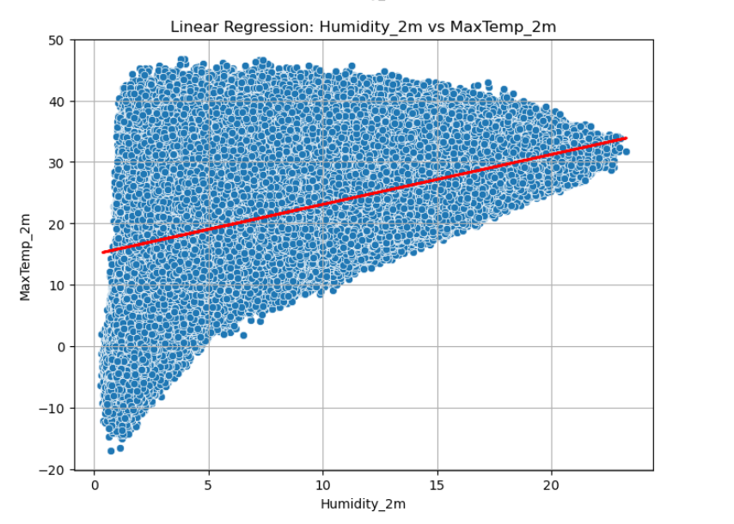

**Conclusion:-**

* Linear regression was used to model the relationship between numerical independent variables and a continuous dependent variable (e.g., predicting 'MaxTemp_2m' based on weather attributes).
* We found that the linear regression model provided a mean squared error (MSE) of 0.6921908717594275, indicating **average** squared difference between the actual binary outcomes and the predicted probabilities.
* Logistic regression was employed to predict a binary outcome (e.g., predicting a categorical variable like 'District' based on weather attributes).